**MySQL Assignment-2**

Fetch the data from the table worker,

1. whose name start with anyone alphabet.

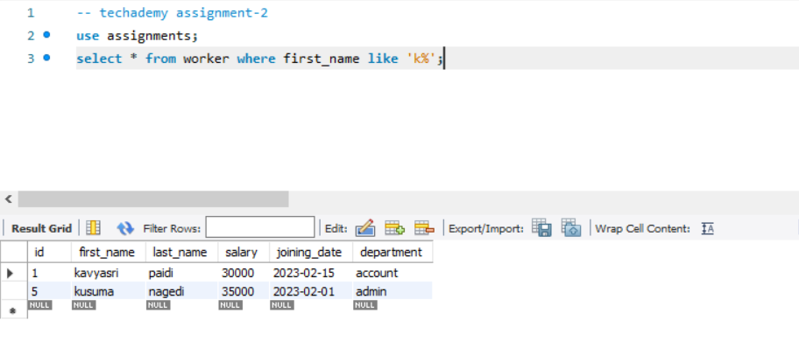

1. use Between operator to fetch the salary of worker

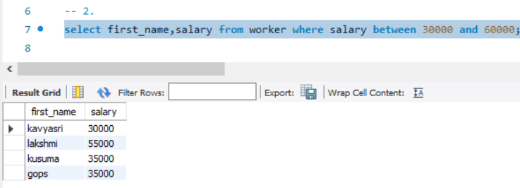

1. use AND operator & the wildcard operator to fetch the data of worker based on their departments &names

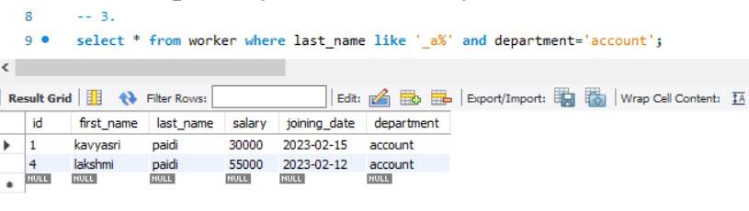

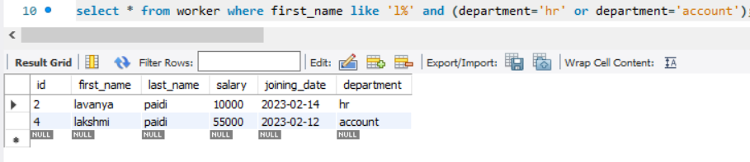

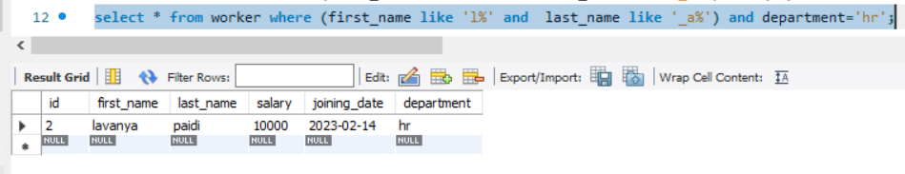

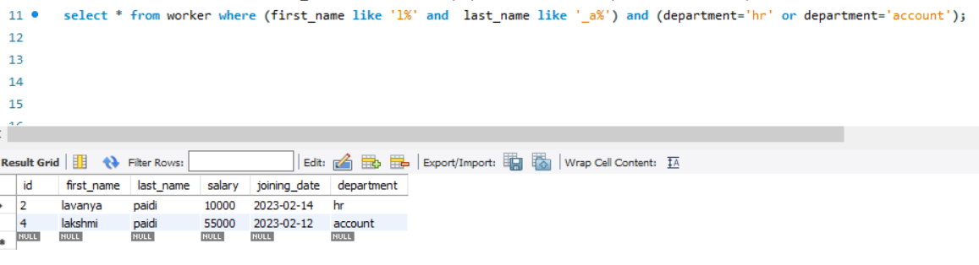

1. Fetch the data by their salary in descending order

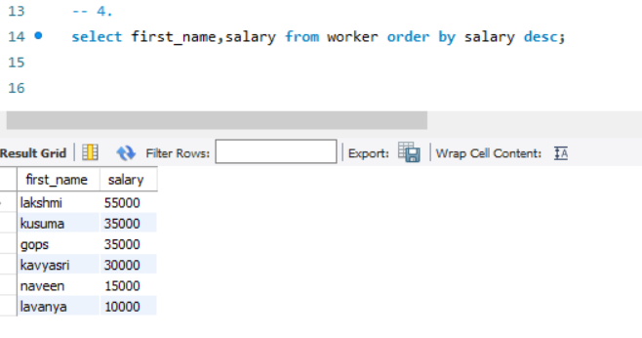

1. calculate the maximum salary from each department where salary should be greater than 50000.

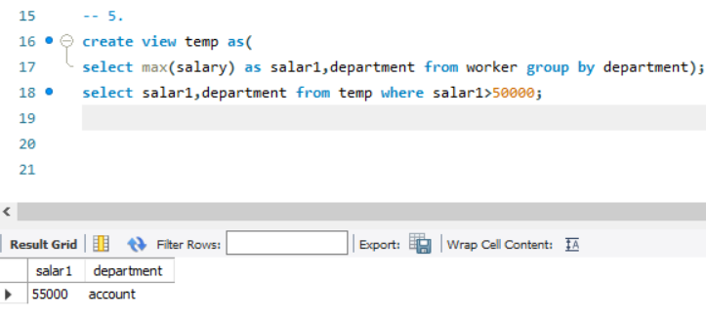

* Title table

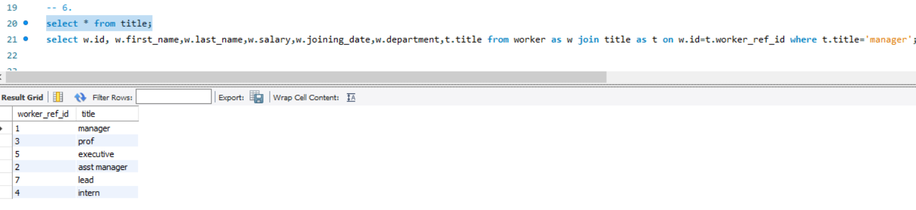

1. write SQL query to fetch details of the workers who are also the managers.

